The Literary Analysis Paragraph Rubric

Explicating Themes and Their Roles in Literature

“A mighty book requires a mighty theme.”
~Herman Melville

Literary analysis is a type of writing where a writer literally breaks a story down to its most basic elements and then analyzes how and why those elements work in that particular story. These elements include identifying important themes, comparing and contrasting stories and authors, defining writing techniques and devices—and anything else that relates to the way in which a story is structured and told. Literary analysis deals only in what can be proved objectively via the text, and not because how and why a certain story makes you—as an individual—think and feel subjectively about that story. The Literary Analysis Paragraph #1 is designed to help any writer find and explicate the major themes in a story and to define the importance of these themes in the story.

The fact that you, as the analyst, are dealing with objective and provable facts is the main reason why most teachers forbid the use of the “I” voice in this type of writing. It is here where I make the distinction between literary analysis and literary reflection: a literary reflection “reflects” your unique emotional and intellectual response to the story; whereas, a literary analysis “analyzes” the form, devices, style, and content of a story. In an analysis, the “I” is not needed and does not help you prove your point because the point is proved using verifiable facts. Throwing yourself into the mix just muddies the water and burdens your writing with unnecessary words and distractions.

The basic structure of the literary analysis paragraph rubric is, however, essentially the same as the narrative paragraph rubric: you open with a clear and concise guiding theme or topic [broad theme, narrow theme, one/two punch]; you offer supporting facts and proof [smoking gun]; and in your third section of the paragraph, you explain and explicate how your guiding theme relates to the story [head and heart]. Finally, you “get on or get out.” If you are writing a single paragraph, you get out with a sense of finality; if you are writing a multi-paragraph essay, you may need to find a way to transition in a logical and unforced way to the next paragraph in your essay.

It is important as a reader, and even more so as a writer, to be able to understand the importance of themes in a piece of literature, for exploring the themes of being human—and being connected (or disconnected) to the rest of humanity is the essential role of any writer! We don’t read because we care about a writer; and if you are a writer, you need to understand that nobody cares about “you” as a person any more than some guy living three towns over from you; however, we do care about ourselves, and if as a writer you put us in touch with a deeper side of our head and heart; if you pull on the strings of our imagination in such a way that we cry when you want us to cry, laugh when you want us to laugh, and think what you want us to think—then you have succeeded as a writer, and those people who do not care about you as a person will care about what you write, and they will beat a path to an door where they can find the pages that hold your words.

Literary Analysis Paragraph Rubric #1

Ten Steps to writing an awesome
Literary Analysis Paragraph

The golden rule of writers is to always know what your readers want and expect—and give it to them in well-crafted writing, which almost always means well-constructed paragraphs! I love using the term “well-crafted” because it implies that writing well requires a deliberate and attentive focus. Good writing is never finished; it is abandoned. Honestly: give yourself ninety minutes to two hours to finish this. A writer’s first words are seldom his or her best words. Over the years I have read and graded thousands of these paragraphs. It is not hard to figure out who gave a damn and who didn’t. It is obvious who reads the details of this rubric before creating his or her own paragraph.

So do your best. Give a damn. It works.

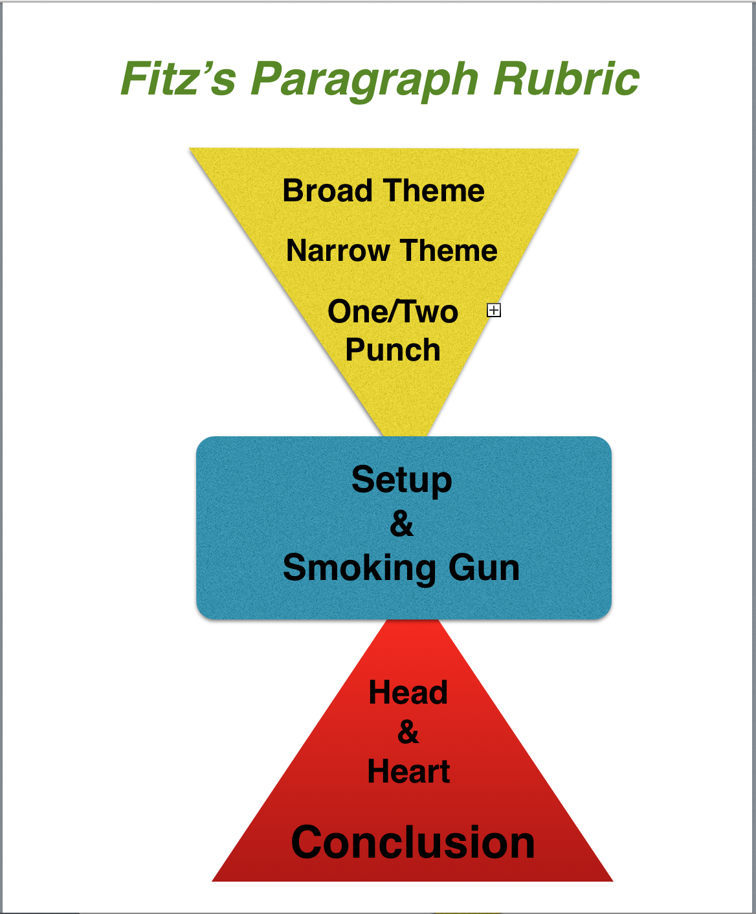
The image below is a visual to help you see
what a detailed paragraph includes:

- The first triangle of the paragraph introduces the theme in a broad way, and then narrows it down to a more focused theme that you can effectively write about in a single paragraph.
- The blue rectangle is the central part of your paragraph. It contains the text reference and text support that “proves” your theme is evident in the actual text.
- The bottom triangle contains the head and heart, which, in many ways, should be the most interesting and thoughtful part of your paragraph. It is where you discuss the importance of the theme in the text support and text reference in the smoking gun. See how (as opposed to the upper triangle) it starts narrow and expands to allow you to logically tie back in to your broad theme in your concluding sentence.

Be sure to follow “all” of the details of the rubric explained in the steps below, and try your hand at a creating a well-crafted literary analysis paragraph—one that we call a “whamdammer” in my class!

In the rubric below, I use an example paragraph written by Ryan Ewing one of my 8th grade students in 2013. The strength of Ryan’s paragraph is not just that it is a good paragraph; it s because he follows the details of the rubric throughout his paragraph. If you wish, replace his text with your own text, then cut and paste your words into a new document and save and submit as required by your teacher.

1. ASSIGNMENT INFORMATION

  - As Mae West said, “It is better to look marvelous than to feel marvelous.”
  - In that spirit, create assignments that “look” good.
  - In the top right corner of your assignment post your name, class, section, assignment name and date.

For Example:

Ryan Ewing
8th Grade English
Section One
Huck Finn Paragraph
5/20/2013

*************************************************

2. THEME

A paragraph needs to have a unifying theme that is developed and explained throughout the paragraph. In this rubric, we are only writing about a single important theme that can be captured n a single word or short phrase.
- Your one word or short phrase theme is the specific aspect of the human condition that is a central theme in the writing piece. It should be centered below your quote and above your opening paragraph in size 18, bold font.
- Your theme should be one word (ideally) or a short phrase—not a full sentence.

For Example:
An Unlikely Friendship

*************************************************

3. MEANINGFUL QUOTE

This quote is by no means “necessary” for a good paragraph, and you would not include it in an essay, but it is a good practice when writing a paragraph, and helps to keep you focused on the theme of your paragraph.
- Choose a quote from the writing piece” that fully captures the theme you wish to explore in your paragraph.
- This quote is the main source for your text reference and text support in your paragraph.
- This can be longer or shorter than you will need or use in your paragraph.
- Center your quote above your paragraph in italics (No quotation marks.) Be sure to cite your source using brackets: For example, [The Odyssey, Book VII, Lines 331-335]

For Example:

Well, I warn't long making him understand I warn't dead. I was ever so glad to see Jim. I warn't lonesome now. I told him I warn't afraid of HIM telling the people where I was. I talked along, but he only set there and looked at me; never said nothing.
[The Adventures of Huckleberry Finn, Chapter VIII]

*************************************************

4. BROAD THEME

This is your first sentence of a body paragraph. In a way, it is almost like the “title” of your paragraph. It is meant to indicate the direction of the paragraph in a compelling and interesting way by creating a clear, concise, and memorable statement of a universal theme—which is, hopefully, interesting and compelling to your potential readers.

- Do not mention the writing piece in this sentence because this sentence is supposed to introduce the theme of your paragraph in a general way that is interesting to a potential reader.
- Oftentimes, especially in a longer, multi-paragraph essay, it makes sense to remove this broad theme, but in a one-paragraph response, I’d leave it in there.

For Example:

  - Nothing beats spending time with a good friend.

*************************************************

5. NARROW THEME

This is essentially the topic sentence of your paragraph—and as such, it is the most important sentence in your paragraph! The Narrow Theme narrows down your theme in a specific way by writing a phrase or sentence that captures how your one-word theme is used in the literature you are analyzing. This is your "clear, concise and memorable" topic sentence.

- Be sure to include a specific reference to the writing piece AND a specific reference to your one word theme in this sentence.
- The narrow theme is the sentence that "steers" your reader in the direction you want him or her to go, and it acts as a reminder to your readers why "exactly" you are writing this paragraph.

For Example:
  - In the book, The Adventures of Huckleberry Finn, by Mark Twain, Huck and Jim grow to be two inseparable friends that set out on a great journey together.

*************************************************

6. ONE/TWO PUNCH

- Follow your Narrow Theme with one or two more sentences (the one/two punch that add detail or explanation to your topic sentence and narrows down the topic even further.
- Beware of creating a series of new topic sentences in your one/two punch.
- At the end of your one/two punch, your readers should have a clear and extremely focused idea of the direction of your paragraph.

For Example:
  - The two companions go through a lot over their time together, but they never give up on each other. Jim and Huck are as different as people can be, physically; however, it is their similar minds that bring them together as friends.

*************************************************

7. SET UP

The setup is the text “reference” that describes in detail (and explicates) the “scene” leading in to your quote (the smoking gun) from the literary piece. The setup and the smoking gun work together to add the “proof” that you have read and studied the piece of literature you are analyzing. Without the smoking gun, you are just rambling around and going nowhere—unless your readers are already fully aware of everything that happens in your piece of literature.

- The setup to your smoking gun should include a who, what , when, where, why reference to a scene from the piece of literature you are analyzing.
- Use specific images and actions to describe the scene leading into the quote (smoking gun!)
- Notice the colon Ryan uses to “introduce” the quote.
- Notice, too, that he describes this scene in the present tense!

For Example:

  - In the first couple of days after he ran away from his pap's house, Huck feels very much alone in the vast world that he is hiding in: no friends, no nothing—that is, before he finds Jim. One day, while Huck is out exploring the island, he stumbles upon Jim's camp; while he is appalled that Jim would run away from Ms. Watson, he is happy that he now has a companion on the island. Even though Jim thinks Huck is a ghost at first, Huck is quick to convince him that he is not:

*************************************************

8. SMOKING GUN

The smoking gun is the quote (text support) you use from the writing piece you are analyzing. A literary analysis without text support
- Text reference (setup) and text support (smoking gun) work together to prove you've read and analyzed the text and prepares your reader for your head and heart section of the paragraph.
- NOTE: Always include the quote reference after your quote in brackets or parentheses. For example: [The Odyssey, Book One, Lines 234-237]
- It is not always necessary to include the title if it is obvious what literary piece you are writing about.
- “If” your quote is less than two lines as it appears in the final text, put quotation marks at the beginning and end of the quote. Put the quote itself in italics. [This is a personal preference of mine and not a universal “rule” because I feel it helps to identify your text support more clearly and cues the reader more effectively that you are utilizing a quote.]
- If the quote is three lines or more, put the quote in italics without quotation marks; put your quote reference under the quote; create a new paragraph for the quote, and finally, indent the whole quote.
- Remember not to indent the first line of the head and heart that comes after the quote because it is still a part of a single paragraph.

For Example:

Well, I warn't long making him understand I warn't dead. I was ever so glad to
see Jim. I warn't lonesome now. I told him I warn't afraid of HIM telling the people
where I was. [The Adventures of Huckleberry Finn, Chapter VIII]

*************************************************

9. HEAD & HEART

This is the “brains & brilliance” part of your paragraph. It shows your reader your how much you know and how insightful you are about your theme and how it used in the literary work you are discussing

- Write at least four sentences that, explicate, illustrate, and elaborate upon your topic sentence and the “Theme” as it used in literary piece, specifically the smoking gun!
- This is where your passion and knowledge come into play. If you don't have much head and heart, then I immediately sense a lazy or ill-prepared student—or even worse….
- Notice that Ryan includes several references to friendship (his theme) in his head and heart—which is especially important in the final sentence leading into his conclusion.
- Many writers, in their quest to sound smart and informed, fall into the trap of introducing new and/or irrelevant topics into a paragraph—usually at this point, or they add in more text support. Don't!!! It distracts and ticks off good readers, and it confuses and frustrates weak readers. Either way, you lose your audience, which is not a good way to earn a living as a writer.
- If you have a new topic that you feel is awesome, then have the decency to give that topic its own paragraph.

For Example:

  - Huck declares a friend as someone who he can trust; by saying that he was not scared of Jim telling on him, he is showing that he trusts Jim as a good friend. He knows that Jim is the kind of person that would comfort him and give him good company - that is exactly what a good friend does. Huck is white kid who hasn't quite yet developed feeling for others. Jim, on the other hand, is a slave; however, their similar taste for adventure is what ultimately makes them friends.

*************************************************

10. GET ON OR GET OUT

This is the concluding sentence or sentences that close out your thoughts (get out) or "transition" to a potential new paragraph (get on). Try to make your conclusion as clear, concise and memorable as your opening sentence.
- If this paragraph is "transitioning" to a new paragraph, (as is usually the case in an essay) craft your words in a way that sets up the next paragraph. This creates what is called "logical flow."
- If the paragraph is simply ending, (as in a brief literature response) try and find a way of tying back into your opening theme in a new and refreshing way. This gives your readers a concise and confident visual and mental cue that you have said all you need to say.
- Be sure—one more time—to include a reference to your theme in the conclusion.

For Example:
- Throughout the rest of the novel, Jim and Huck remain close friends. They come to realize that neither of them could have evaded capture for so long if it weren't for their friendship. For Huck and Jim, their friendship has allowed them to succeed and thrive together on a difficult journey.

Cut and paste it all together, and it should look something like this: I color coded each section to highlight the various steps of the rubric. I also put in bold each time Ryan emphasize the unifying theme. Yuma find it helpful to do this as well.

Ryan Ewing
8th Grade Fitz English
Section One
Huck Finn Paragraph
5/20/2013

An Unlikely Friendship

Well, I warn't long making him understand I warn't dead. I was ever so glad to see Jim. I warn't lonesome now. I told him I warn't afraid of HIM telling the people where I was. I talked along, but he only set there and looked at me; never said nothing. [The Adventures of Huckleberry Finn, Chapter VIII]
Nothing beats spending time with a good friend. In the book, The Adventures of Huckleberry Finn, by Mark Twain, Huck and Jim grow to be two inseparable friends that set out on a great journey together. The two companions go through a lot over their time together, but they never give up on each other. They are as different as people can be, physically; however, it is their similar minds that bring them together as friends. In the first couple of days after he ran away from his pap's house, Huck feels very much alone in the vast world that he is hiding in; no friends, no nothing—that is, before he finds Jim! One day, while Huck is out exploring the island, he stumbles upon Jim's camp; while he is appalled that Jim would run away from Ms. Watson, he is happy that he now has a companion on the island. Even though Jim thinks Huck is a ghost at first, Huck is quick to convince him that he is not:
"Well, I warn't long making him understand I warn't dead. I was ever so glad to
see Jim. I warn't lonesome now. I told him I warn't afraid of HIM telling the people
where I was." [The Adventures of Huckleberry Finn, Chapter VIII]
Huck declares a friend as someone whom he can trust; by saying that he was not scared of Jim telling on him, he is showing that he trusts Jim as a good friend. He knows that Jim is the kind of person that would comfort him and give him good company—and that is exactly what a good friend does. Huck is white kid who hasn't quite yet developed feeling for the black slaves that have been so much a part of his life. Jim, on the other hand, is a slave; however, their similar taste for adventure is what ultimately makes them friends. Throughout the rest of the novel, Jim and Huck remain close friends. They come to realize that neither of them could have evaded capture for so long if it weren't for their friendship. For Huck and Jim, their friendship has allowed them to succeed and thrive together on a difficult journey.

THE RULE OF THREE:
- A writing piece is never finished. It is abandoned. Once you are this far, now is the time to go back, edit, revise and to do whatever needs to be done to make this a worthy and enduring piece of literature in its own right.
- Find three areas or sentences that you can make better. If you can't or won't do this, then you are light years away from being a writer.
- Often you can find a better broad or narrow theme sentence somewhere else in the paragraph. You can almost always find a more clear and effective way to write a sentence than you wrote on your first try.
- Be sure to read the paragraph aloud, use text to speech to listen, consider making it into a podcast, share it on your blog, and/or post it to your portfolio because you are the writer now. This paragraph is your gift to the world.
- If the rule of three was too easy (meaning you easily found mistakes) do it again...and again if you have to.

©Created by John Fitzsimmons
TheCraftedWord.org

